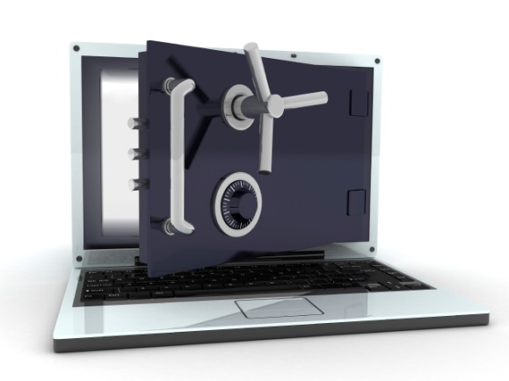

Our Title Company

The Security You Need From Your Title Company

There’s a new set of security standards for the real estate industry. At Our Title Company, we’re committed to keeping our customers ahead of the curve by providing industry leading document security for this new environment.

Our Title Company has now partnered with Pioneer Technology Group , a leading developer of secure technology for real estate, courts, and registers of deeds, to provide our customers with the YourDox platform. With our exclusive technology, all documents and files are protected by industry leading data security, giving you the assurance and protection you need.

By closing with Our Title Company, your documents and information are secured with:
- User name and password authorization required for all file access
- 256 bit encryption standard for all file activity and document delivery
- All files, documents and data housed at SSAE 16 type II Certified Data Center
- Data Center is independently audited annually and inspected on a daily basis
- All employees subject to screening and adherence to written security policies
- Facility access monitored by video, keycard, and biometric scanning

At Our Title Company, we understand what it takes to help you meet the new security standards - we’re committed to providing you and your customers with industry leading document and data security on every single closing.

For more information, call Our Title Company or visit us online at www.ourtitlecompany.com

